***Volume 19 – Issue 3***

***2020 Board of Directors:***

**President – Sam Gray**

**Vice President – Max Saus**

**Secretary – Ron Bowman**

**Treasurer – Cyndie Smith**

**Dir. at Large – Mike Flanagan**

an02097_

The Lake Heron" Banner"

*Lake Heron is a welcoming, caring, vibrant and well managed community we call home.*

|  |
| --- |
| **C:\Users\Dee\AppData\Local\Microsoft\Windows\Temporary Internet Files\Content.IE5\SJ8GFP89\St.-Patricks-day-plates-500x500[1].jpg**  **\*\*\*\*\*\*\*\*\*\*\*\*\*\*\*\*\*\*\*\*\*\*\*\*\*\***  Email your articles for the next issue to  Dee Ryder at **Dee\_Ryder@Verizon.net**  put ***"For The Banner"*** in the Subject line *Please* …  Only emailed items will be accepted.  ***April 2021 Banner Deadline is March 26, 2021*** |

ite

Lake Heron HOA does not recommend nor endorse any advertisement printed in the Banner.



christmd

***March***

***Board Meeting* will be on**

***March 8, 2021*  at**

***4:00 PM* on ZOOM.**

***President’s Corner***

**Reminder**: March 08, 2021 Board Meeting at 4:00 PM will be a Virtual Meeting on Zoom. Sign in directions are in the Banner (Just below the President's Corner).

The Farmers’ Almanac leads us to believe that March comes in like a Lion and goes out like a Lamb. Let’s hope.

Pasco County has not given us a date on the LH COVID-19 vaccines. Therefore, if other vaccine locations become available please take advantage of these sources. I am hopeful that we are nearing the top of Pasco’s list and thank each LH resident for their patience in waiting.

Health officials tell us that vaccines will not stop the COVID virus, but vaccinations will most likely keep us from being hospitalized or our health seriously impacted if we contract it. Medical experts predict that mask requirements, social distancing, and limited socialization will be needed throughout 2021 regardless of what government opens to stimulate the economy. The world is not out of the woods yet.

If any signed up individual elects NOT to participate in the LH vaccination program due to being vaccinated elsewhere, please, notify me to remove your name from our list. Contact Sam Gray, 607-738-2137immediately as vaccine doses are precious.

Have a Happy Saint Patrick’s Day. Wear your green, drink a little green beer, indulge in corn beef-n-cabbage, and dance the jig.

Stay healthy and safe,

~Sam Gray

Email: LH.President99@gmail.com

PH: 607-738-2137

***Information To Set Up Zoom For Lake Heron Meetings***

In order to attend the Zoom meeting you will need to download the [Zoom.us](http://zoom.us/) app by going to [www.zoom.us/download](http://www.zoom.us/download) and click to sign up.

You will need a camera and a microphone on your computer in order to participate.

On the scheduled date and time of the meeting you would click on join a meeting and you will be asked for the following information in order to be a part of the meeting:

**MEETING ID: 219 022 5906    /     PASSCODE:  2020**

***In Case You Didn’t Know.....***

We have a group page to share news, announcements, and pics about our community. No board business, no solicitation, just fun goings on and an occasional neighbor helping neighbor. You must be a resident of Lake Heron, Take a look, answer the questions, like and follow!

https://www.facebook.com/groups/1030502940660468/

***Financial Results for 2020***

    Going into the year 2020 we did not know what effect the virus pandemic would have on Lake Heron’s finances.  Your board of directors took steps to conserve expenditures early in the year until we had a better idea of how cash flow would be affected.  Fortunately your community came through in good shape financially.

    The year-end financial statement is now available through UPI.  Here is a quick summary:

Cash plus reserves  -  $988,873

Liabilities      -      $907,762

Retained Revenue    -  $81,122

    (NOTE  -  Of Retained Revenue above,  $32,202 is a result of 2020 expenses and $48,918 from prior years.)

    Retained Revenue is a result of two things; lower than expected expenses, and higher than projected income.  In 2020,  the $32,202 mentioned above is almost exclusively the result of spending less, as we had $1,812 less income than anticipated.  Having noted that, Lake Heron had a very good financial outcome in 2020.

    Your board of directors operate nearly a million dollar business.  (99% of a million.)  Together with the value of our property Lake Heron is easily a 2 million dollar asset which, together with the professional management of UPI, is managed by volunteers.  Your monthly assessment is one of the most efficient expenses in your cost of living.

***News About Our Clubhouse***

As you know the clubhouse has been closed for the past year due to Covid-19 restrictions.  We can’t predict when it will reopen and when we can again have our popular social gatherings, but it will reopen as soon as the community can safely gather in one place.

In the meantime your REC Committee will use this down time to refresh elements of the clubhouse and make some improvements.  We plan to improve the lighting in the woman’s restroom and improve the light switches in both restrooms.  There is some touch up painting to be done both inside and outside.

Of a more long term consideration your committee is investigating replacing all the restroom sinks.  They are approximately 25 years old.   We can improve the lifetime of our pool deck surface by adding rain gutters to the pool side of the building.  Several years ago we did gutter the east side of the building.

***MINUTES***

***February 08, 2021******Lake Heron HOA, BOD Meeting***

Call to order:  4:00 PM (Virtual Meeting in Zoom)

Roll call: ***Sam, Ron, Max, Cyndie, Mike***   **Quorum Established**

Proof of Due Notice Posted: 48 Hrs.

Motion to forego reading prev. Minutes: Cyndie, 2nd Sam **Approved: 5/0**

**COMMITTEE REPORTS:**

**President:  Sam,**Discussed schedule of annually budgeted tasks. (Palm tree trimming, power washing bldgs., mulching of common areas, re-painting of resident’s front doors)

**Finance**:**Cyndie,**2020 End of Year net income approx. $32,000.

**Treasurer: Cyndie,**Gave monthly report. $904, Net Income

**ACC: Pam:**No new submissions to ACC

**Rec. Ctr: Ed:** Pool and heater, repaired and running.

**RV Park: Max:**1 space available

**Park Team:  Pam,**Discussed park security, reports of petty theft, vandalism. Discussed adding solar lights to park areas.

**Grounds: Ruth:**No Report.

**Parking Enforce:** **Linn.** No report

**Social: Sheryl:**No Report.

**Old Business**: Power washing to begin February 22, 2021

**New Business**: Motion to pay Larry Kelly, $650, to power wash brick wall along Lake Floyd Drive. ***Motion approved 5/0***

**Meeting Adjourn: 4:55**PM , Next Meeting: Mar 08,2021 7PM (Virtual)



***The evolution of Covid-19*** ﻿

Covid 19 continues with a vengeance, as you all know. It is killing more Americans than heart disease and cancer, the major causes of death in the US. And vaccines, it seemed, were easier to manufacture than getting them to Americans and into their arms has proven to be. The enormity of logistical challenges, such as storage of vaccines requiring varying temperatures, differing shelf lives, transport of vaccine lots, confusion in leadership, disorganization, and others have tripped up the vaccination process. At the time of this writing, in the US it is estimated that only 3 to 4% of vaccinees receiving a 2 dose vaccine have received the second dose. People are enduring long waits at many, if not most, vaccination centers.  But we have learned a lot and I believe vaccine distribution will improve.    Once your opportunity to get vaccinated arrives,  it is critical that each of you receive both doses of the vaccine in order to assure maximal immunity. One dose is not enough!

On the bright side, progress is being seen. We are exceeding President Biden’s goal of 1 million vaccine doses given per day . Cases, hospitalizations, and deaths are beginning to trend down due to, so the experts tell us, vaccination, immunity due to prior infection, and increasing adherence to mitigation measures, such as masking. The vaccines themselves are proving to be exceedingly safe to date. Some experts are predicting herd immunity(70 to 80% of the population immune) by the end of the summer, in which case life could take on a semblance of normalcy.

Major challenges still remain, however. All viruses mutate all the time. The original virus, SARS Cov 2, against which most vaccines are directed, has begun to mutate. In this process, virus alters its genetic makeup, sometimes producing new  mutants called “variants”which are partially or wholly resistant to existing vaccines, and thus able to infect an already vaccinated human host .

The known major viral variants are 3; each named for its presumed place of origin; the UK variant, the Brazil variant, and the South African variant. One other is the California variant.  All 3 major variants have been detected in the US, and given past experience, will spread rapidly. The UK virus is expected to be the most widespread. These “variant” viruses may prove to be more infectious, more lethal, or both, than the so-called “wild” virus, against which our current vaccines are directed. Whether, and to what extent, the vaccines currently in use in the US, Moderna and Pfizer, will be effective against the variants is unknown at this point in time.  But most experts believe that existing vaccines will prevent infections from viral variants at least to some degree, perhaps by preventing serious illness, hospitalizations and deaths. Because of the presence of variants, and the expectation that they will be widespread in the US, mitigation measures, such as masking and distancing, must continue for now, even after initial vaccination. I know this is deeply disappointing to all of you, but we must continue to be vigilant.  Moderna and Pfizer, as well as the National Institutes of Health,  are currently formulating boosters that would prevent infection by the variants.  Doing so should be fairly easy, as few changes would be needed in the current vaccines to make these boosters. Scientists in the US have also stepped up “genome sequencing”,  a method of surveillance to detect new variants that may arise so that we may alter our vaccines or produce boosters for them, if needed.

Get vaccinated as quickly as possible to protect yourself and others. If we eliminate human hosts for the viruses by making people  immune, viruses will have no means by which to replicate, which can only occur if infection takes place. This also prevents mutations, which can only occur if viral replication occurs, and mutations can result in virus resistant to vaccines.

~Bram Smith, MD

***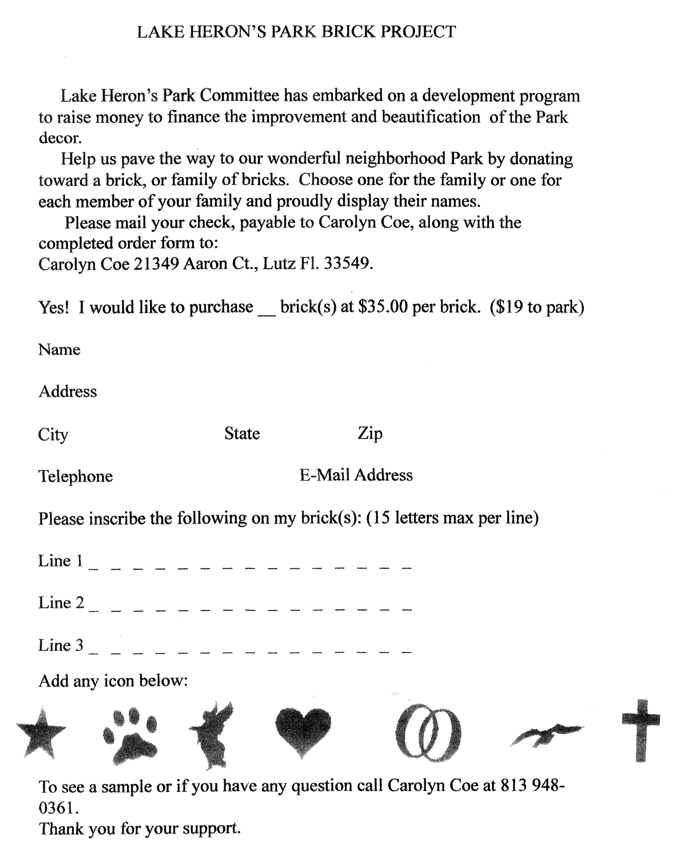***

**Please see contact information at the bottom of this form**

**To see a sample or if you have any questions call**

**Ruth Copeland at .. (813) 948-0854**

**E-mail…….Ruth@Copelandhome.net**

***Thank you for your support***

***Garbage and Recycling***

If you recycle, you ***CAN NOT*** use any bags.

You ***MUST*** use a dedicated container (tub or can).

***The Recycling will be picked up every Wednesday, usually before 7am***

The truck crews will pass by any container that has plastic bags.

We see more and more bags being left out for curbside pick up, and those bags are being ignored.

Your recycle container should have a “Recycle Sticker” on it.

The stickers can be obtained by calling **727-856-4539**.

***Reminder – When Home or Away***

You can still get The Banner and keep up with Lake Heron news by accessing the Lake Heron website.

Access to Lake Heron Web Page

1. Type into your internet search page **“univprop.com”**
2. Locate **“Association Pages”** in the contents list in the left border
3. Lake Heron’s number is 4350. Put your mouse in the number list and scroll down to 4350 and click on it.
4. The website will now open with the calendar of events for the clubhouse.  To reach other pages just scroll down (or Page Down).

On our web page you’ll find copies of The Banner, Board Minutes, Directors and committee Chairpersons. Our standardized forms in printable copies are on the web page.

**CHANGE**

Reservation requests for the Community Center (Clubhouse) **MUST**be by email.

Phone call requests will not be accepted.  Email [clubhouseguy1321@aol.com](mailto:clubhouseguy1321@aol.com)

***RECYCLING BIN***

The Lake Heron recycling bin has been removed.  You can add paper and cardboard to you curbside recycling pickup every Wednesday of each month.

Thank you.

******

***HOA Dues***

Homeowners can now pay association dues with credit cards if they wish.

Simply go to **www.univprop.com** and click on pay credit card payment and follow the link.

Visa, Master Card, American Express and Discover Card may be used.

If the homeowner does use the credit card there is a 5% convenience fee the homeowner is charged.

***Lake Heron Contact Information*:**

***Property Manager*** - Angela Hester

University Properties Inc. 813-980-1000

or email her at... ahester@univprop.com

***Website* -** Univprop.com - HOA# "4350"

***Volunteers* *Name***

**Board (President) Sam Gray**

**Board (VP) Max Saus**

**Board (Secretary) Ron Bowman**

**Board (Treasurer) Cyndie Smith**

**Board (Director A.L.) Mike Flanagan**

**Park**

Ron & Lori Bowman Kathy & Sam Gray

Pam Schwebl Ruth Copeland

Don Bushkie Linn Torres

Bonnie Mikulla Maxine Pickert

Susan Hoelseggen Lee Carter

Pam Kelly

**Social Committee**

Sheryl and Ron Spencer Cyndie and Bram Smith

**Newsletter Delivery**

Vickie Morris Beverly Patterson

Betsy Nehr Sherry Williamson

John Copeland Maria Saldarriaga

Hoke Cash

**Newsletter** Dee Ryder

**Grounds**

Don Bushkie Ruth Copeland (Irrigation)

**Architectural Control** Pam Kelley (Chairperson)

Matt Boisvert

Rachel Powers

Bill Prall

**Finance**

Kathy Gray Cyndie Smith

John Copeland

**RV Park**

Max Saus (Chairperson) Larry Kelly   
Hoke Cash

**Community Center**

Ed Martinell

John Copeland

**Wright Termite & Pest Control - 813-948-0229**